Conservation propagation of Cotoneaster cambricus
One of the jewels in the crown of our collections at the Botanic Garden sprawls across the top of the Rock Garden, a plant only an enthusiast could love, with straggly, bare stems, sparse foliage and a form which is best described as ‘messy’: Cotoneaster cambricus (Creigafal y Gogarth - Gogarth Rock Apple). Such an ugly specimen is a prime candidate for grubbing out for the bonfire, surely? *

The root of the problem
Looking back through time, our avaricious Victorian predecessors felt very differently to me about the aesthetic appeal of this species. In its only native habitat – the Great Orme, Llandudno - it is a lot more compact and less straggly looking and plant collectors were enchanted by its fuzzy, greyish leaves and dazzlingly bright red fruits. Unfortunately this appeal led to its demise, and over-collection of endemic Cotoneaster cambricus - once widespread on the Great Orme - resulted in its status today as Critically Endangered. (IUCN, 2019). Just six original plants now survive on the Great Orme, which have been supplemented with cultivated plants bringing the total to around 80 plants in situ. These plants are not regenerating naturally, due to grazing causing reduction in size and flowering of mature plants, and preventing establishment of any seedlings. (Pidcock, S. 2013). Further specimens exist in ex situ locations (including our own two enormous plants) providing a ‘back-up’ population.

A rose by any other name
I feel that I should mention that there has been considerable debate about C. cambricus, (including during at least one lunchtime here at TBG) as it was long believed by some taxonomists to be the widespread eastern European C. integerrimus, no doubt causing much arguing over hand lenses and field guides. However, genetic studies undertaken by RBG Kew concluded that although similar to C. integerrimus, C. cambricus is indeed a distinct species, and in fact has the accolade of being the UK’s only native Cotoneaster. (Pidcock, S. 2013).

Treborth’s specimens
The table below, from Treborth Botanic Garden’s plant collections database, contains the sum total of information I’ve been able to find to date about our own magnificent specimens. (Thanks to Nigel Brown, former Curator TBG, for providing this).
Accession number | Notes
496 | The older of the two specimens. 'Collected' by Len Beer from the Happy Valley area of the Great Orme in early 1970s when there first was an interest in propagating this taxon for conservation purposes. Len Beer planted it out in the garden but it struggled. After Nigel Brown took over, he dug it up and potted it to ensure its survival. It remained potted for a good few years and then was later planted out on the rock garden, probably about the mid 1980s.
4326 | The younger of the two specimens. The origin of its parent is the Great Orme and is one of the remaining native plants. It was germinated from seed at Ness Botanic Garden who shared some of their successes in the 1980s with TBG. This specimen was originally given the same accession no, as the older specimen (496). It was allocated a separate Acc. No. in July 2019 as the plant is from a different source and donor.
Fig. 1: Treborth Botanic Garden plant collections database entry for Cotoneaster cambricus (Brown, N. 2019).

Conservation partnership
Treborth Botanic Garden is involved in a partnership between the Botanical Society of Britain and Ireland, Chester Zoo, Conwy County Borough Council, National Botanic Garden of Wales, and Natural Resources Wales, which aims to increase the numbers of C. cambricus on the Great Orme to 200.
In June 2019, the Treborth crew (me and Natalie, and interns Sarah Ellis, Stewart Turtill and Roseanna Hunt) headed out into the mizzle and ascended the Great Orme to join Sally Pidcock from Conwy Council, Tom Parry (local resident and propagator of many C. cambricus progeny) Caernarfonshire County Recorder Wendy McCarthy, Robbie Blackhall – Miles of Fossil Plants, and Richard Hewitt and his colleagues from Chester Zoo. We meandered our way through flower-rich pasture, stopping every few metres to squint / sniff at a variety of gorgeous blooms, such as Helianthemum nummularium which was carpeting the slopes and a solitary spike of Gymnadenia conopsea (the Fragrant Orchid – which really does what it says on the label!)
Our goal was to plant out two luscious specimens which were produced by Richard Hewitt and his nursery team at Chester Zoo. Much to my annoyance, these healthy, vigorous looking specimens were germinated at the same time as my own first batch – but mine are just a couple of inches tall and seem reluctant to continue to grow, while Richard’s are so lovely I could go all Victorian over them. As we searched for a suitable planting spot for the new arrivals, we were able to see the existing population. This consisted of squat, bonsai-looking plants, which had been miniaturised by the attentions of goats and rabbits. C. cambricus is notoriously hard to germinate (my first year’s efforts yielded just under 4% germination, the subsequent year’s outcome is looking to be around 0.6%, and establishment of the seedlings is a struggle) but the primary problem in situ is clearly that the flowers and any surviving fruits are being grazed off before there is any chance of seed maturing and germinating. Our huge plants at the Botanic Garden flower and fruit prolifically in their luxurious deep soil, but we are infested with rabbits (the Rock Garden being one of their favourite dining spots), so although the plants are so large that many of their flowers are raised up to around a metre from the ground, allowing them to produce abundant fruit, I suspect that any seedlings which may manage to initiate in the vicinity will soon be massacred by the furry pests. Natalie and I can fence off our plants in future to see if this helps, but protecting plants with fencing on the Orme is not a realistic option for Sally – it would be unmanageable within the current management methods and their limited resources. Sally persists in harvesting the few berries which survive on the Orme plants, and distributes them amongst members of the partnership to propagate under nursery conditions. She and her allies have done a remarkable job to date, and the more I try to force this ungrateful species to germinate and establish, the more I admire their success.

The future
Here at TBG, we strongly believe that the best way to protect a plant is to share it. In 2018 I gave seed from our C. cambricus to NBGW, Chester Zoo and RBG Kew, and sent Carly Green, propagator from NBGW home with numerous of our reluctant seedlings. Earlier this year I received an email from the Millennium Seed Bank at Wakehurst Place, who are keen to obtain a large quantity of ‘pure’ seed from C. cambricus. One of the considerations with this species is hybridisation, because although it has long been thought to be solely apomictic (reproducing asexually, without fertilization), propagators agree that it can also reproduce sexually, therefore allowing it not only to reproduce with its own species, but to hybridise with other compatible Cotoneaster species. This has been in my mind whilst I’ve been working on germinating seeds from our plants at TBG, as there is no shortage of other Cotoneaster species in the vicinity, and personally I don’t have enough experience with the species to recognise its natural variations. Therefore this year I have attempted controlled pollination of our plants to ensure that the seed is the genuine article. Lack of genetic diversity will be a problem with this method, as with taking cuttings from our plants. Even if we are able to cross pollinate plants within the current population, it is such a small gene pool that genetic diversity would be negligible. Ironically, this may be one reason that this species has such a poor rate of germination, so arguably hybridisation could actually be its best chance of survival; part of its evolutionary journey. I find that this species raises many questions that I just can’t answer, but by both banking seeds and producing seedlings for in situ and ex situ conservation, we can at least preserve living material for further research and conservation. I my mind at least, the path we choose for this plant and its genes to take is not yet clearly defined.
Throughout my efforts to find the best technique for germinating this species I’ve found remarkably little published information. Common sense told me that scarification and stratification would be a good starting point, which was borne out in the results of my initial trials, though still didn’t yield incredible success rates. Treatments with gibberelic acid, hydrogen peroxide and the addition of lime don’t seem to have been successful so far, though I will retain the pots in case they take years to germinate. Local botanist Robbie Blackhall-Miles has been generous in sharing his expertise with me to conduct these trials together, and we plan to work together with the other partners to create a germination protocol, which we hope will be another means of aiding the survival of this rare endemic. We feel that information sharing is a critical part of this plant’s future, and the partnership has enabled this to happen.
At this stage I can only say that Cotoneaster cambricus seems to be a species which resists propagation with remarkable determination, but I’ve learned to love (well, like at least) this frustrating, ugly plant, and I am glad to be part of the partnership supporting its survival, whatever form that may take.

Rosie Kressman, Horticultural Technician
* I’m notoriously intolerant of crap plants. For the record I am, however, fairly selective as to what I actually incinerate.

References
- iucnredlist.org (2019). Great Orme Berry. [online] Available at: https://www.iucnredlist.org/species/102827479/102827485 [Accessed 28th July 2019].
- Pidcock, S. (2013). Species Action Plan Wild Cotoneaster. [online] Available at: https://web.archive.org/web/20070927064747/http://www.conwy.gov.uk/upload/public/attachments/48/WildCotoneasterv2.pdf
- Brown, N. (2019). Cotoneaster cambricus. Treborth Botanic Garden plant collections database. Available by request at Curator’s discretion. [Accessed 28th July 2019].

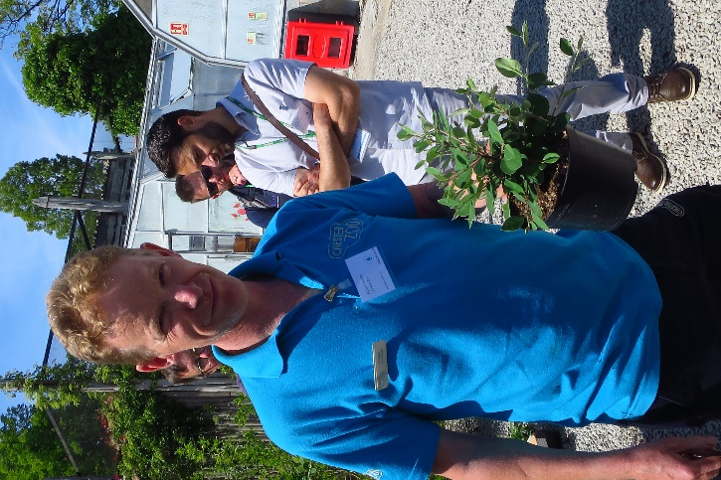
Chester Zoo nursery manager Richard Hewitt with C. cambricus germinated in 2018, photo taken May 2019
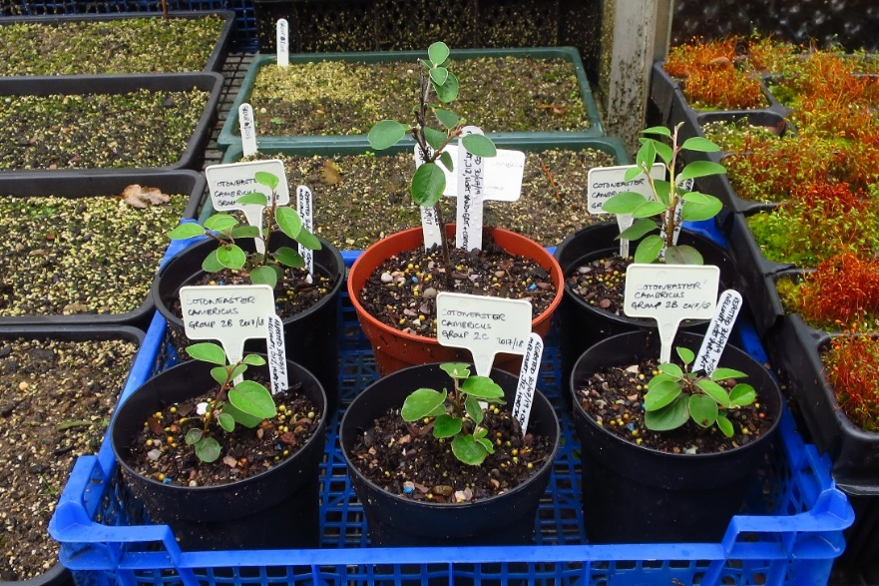
Cotoneaster cambricus seedlings germinated in 2018, and one cutting taken in 2018. Note that these are the same age as the plant Richard Hewitt is holding in the other photo!
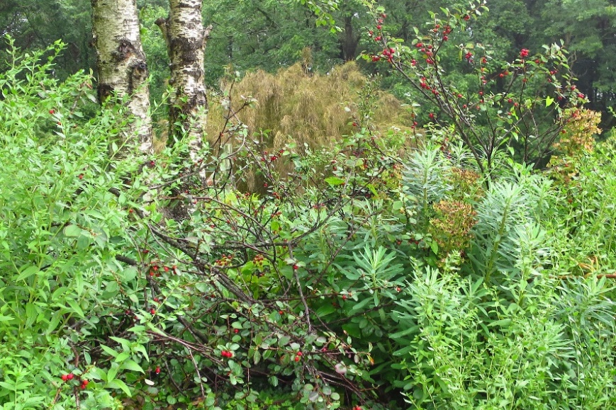
One of the two mature Cotoneaster cambricus specimens at Treborth Botanic Garden

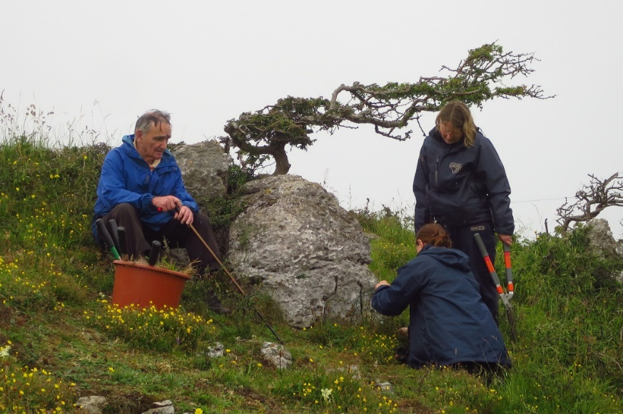
Tom Parry with horticulturists from Chester Zoo, checking and clearing around the plants on the Great Orme

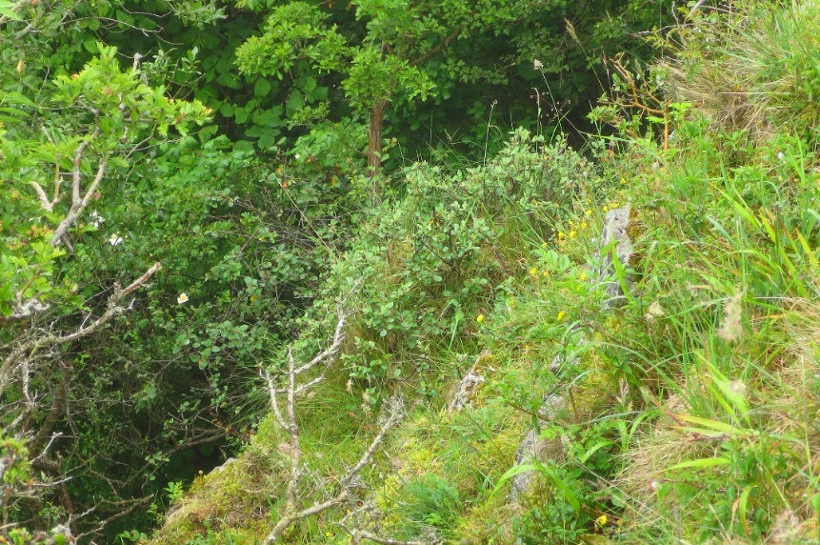
One of the original Great Orme plants, clinging to the limestone cliff

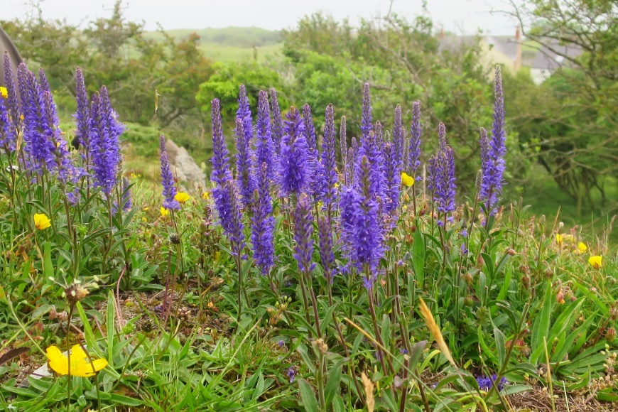
Veronica spicata (spiked speedwell) gracing the slopes of the Great Orme

